Assignment-25.1:

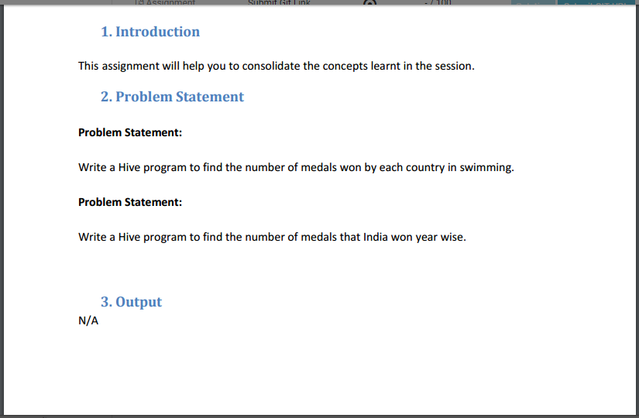

A table named Olympic is created and the data is loaded into the table. The columns of the Olympic table is described below

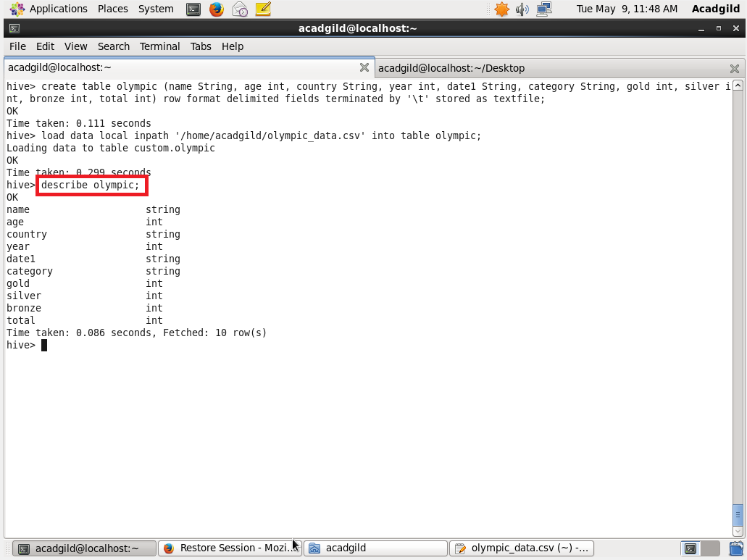

Write a Hive program to find the number of medals won by each country in swimming.

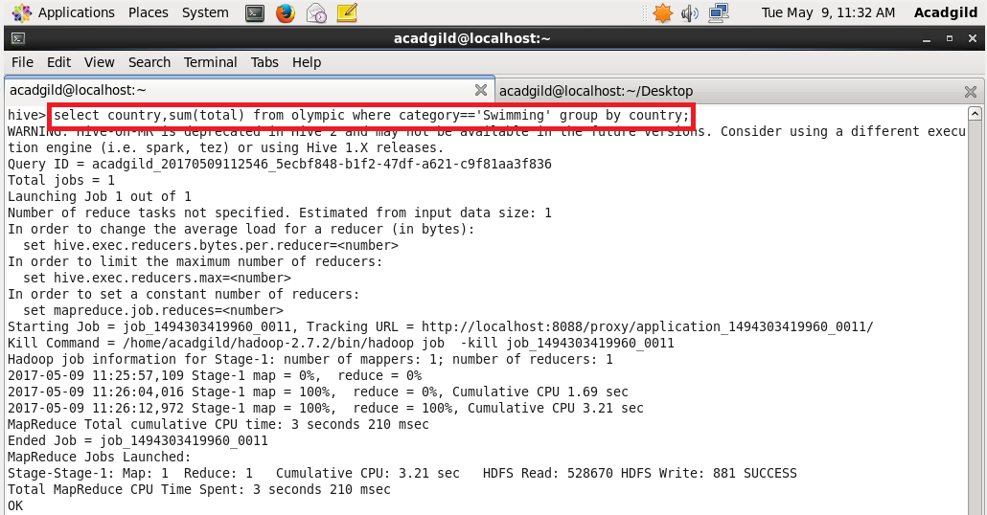

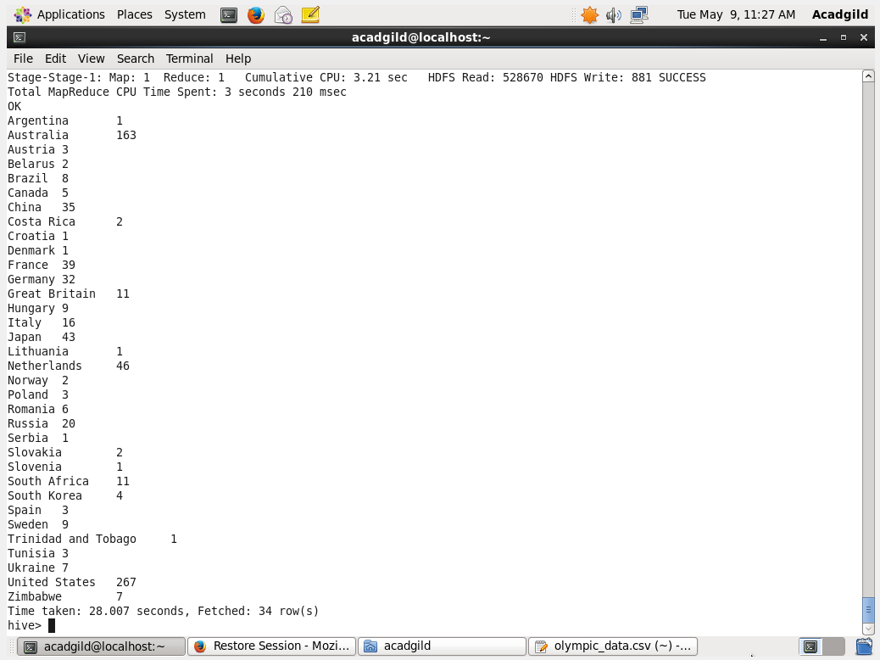

Write a Hive program to find the number of medals that India won year wise.

